Exercise 2:
MY sql database: 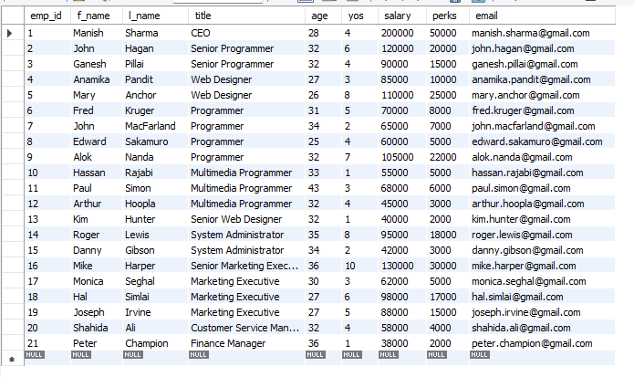
- SELECT emp_id FROM employee_data WHERE age > 30;
- SELECT f_name, l_name FROM employee_data WHERE title = 'Web Designer';
- It displays all columns of employees whose salary is less than or equal to 100,000.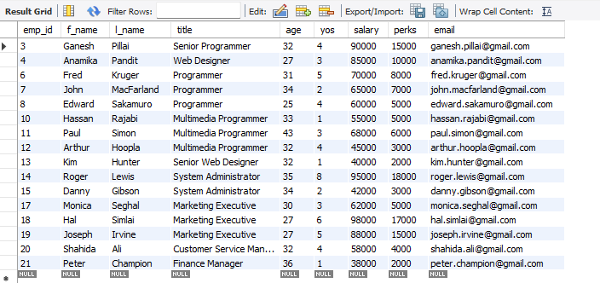
- SELECT f_name, l_name, salary, perks FROM employee_data WHERE perks > 16000;
- SELECT CONCAT(l_name, ' ', f_name) AS full_nameFROM employee_dataWHERE title = 'Marketing Executive';

